The Army Learning Management System (ALMS) Hint Guide
Tips for Successfully Completing a Course on ALMS

Version 1.0
March 2013

Purpose
The purpose of this solution guide is to help students’ successfully complete Defense Ammunition Center (DAC) online training courses in the Army Learning Management System (ALMS). Table 1 provides guidance and solutions for resolving frequently reported problems. For problems or issues not addressed in this guide, please contact the ALMS Help Desk.
Table 1. Solution Guide
Question/problem | Possible solution/comment
Who can I call for assistance? | - For problems with ALMS system, call the ALMS Help Desk: Toll Free: 1-877-251-0730; DSN: 826-4745 (open 0700–1600 EST). Select option #4 for ALMS course-related technical issues.  - If the ALMS number doesn’t work, call the Army Training Help Desk: Toll Free: 800-275-2872, Option #1; DSN: 826-3666; (open M–F, 0700–1600 EST).  - For problems with your AKO user ID or password, call the AKO Help Desk at 1-866-335-ARMY (2769).
I don’t see where I can launch the course. | - Click on the “plus” box inside the pop-up screen until a launch button appears. See Appendix A Figure 2.
When I try to launch the course, I get the message “Web page not available” or “Error 404 (File Not Found).” | The course has been taken off-line for maintenance, or the ALMS is unavailable or experiencing problems. Check with the ALMS Help Desk.
After launching the course, I still have browser information (bars) at the top and bottom of the screen. | Press F11 to go to full screen mode. Pull down the View Menu and uncheck the Status Bar box to eliminate the lower bar. If the F11 key does not work, the option for full screen mode is also in the View Menu.
After launching the course, the Content and Results page appears, with the message “You cannot mark the course complete” or similar message. | The ALMS is running slowly. Please wait for the Table of Contents to appear in the upper left corner of the screen. In high traffic times, network response can be very slow, especially for large courses.
My screens look distorted and/or do not match those in the text. | Make sure your screen is full size, and that the resolution is set to 1024 × 768 pixels, even if your screen will support a higher resolution. Color quality should be set to High (32-bit). Dots per inch (DPI) must be set to 96 (the default). Remember to apply your settings before exiting the Display Properties screen. Also, check the ZOOM indicator in the lower right corner of the screen to be sure it is set at 100%.
I’m getting a blank white screen between course screens, or screens are forming slowly. | This is normal for course materials constructed for SCORM compatibility and displayed on the ALMS website. How fast the slides change is dictated by network load, and is not under ALMS control. A delay of 3–5 seconds may occur, if the network is busy.
I get pop-ups warning me that the screens contain “non-secure” material. | Click Yes whenever the pop-up appears.
I’m stuck! My system appears to be frozen. | If there has been no response to a simple “turn the page” action for 60+ seconds, close the lesson by clicking the Close icon in the upper right corner of the screen. You can try relaunching the course from the Table of Contents, or closing the ALMS completely and logging in again. If the problem persists, call the ALMS Help Desk.
The course I am trying to take will not load. | Ensure your system is updated to the correct Internet Explorer (IE) version. When you log into ALMS, you will see a box titled “Browser Settings.” Click this box to verify your system meets all the ALMS recommended settings (e.g., operating system [OS], IE, Flash, pop-up blocker off).
My course appears to lock up at a certain screen, preventing further progress. | Confirm you have clicked through all previous screens. If yes, contact the ALMS Help Desk for assistance. If there is an issue with the platform functionality, the Help Desk will provide instructions for completing the course via an alternate website.
After progressing through a course, the course restarts at the beginning. | Exit the course and resign back into ALMS to try and resume at your last save point. If your progress is not saved, contact the ALMS Help Desk for assistance. If there is an issue with the platform functionality, the Help Desk will provide instructions for completing the course via an alternate website.
Can I exit the course and then pick up where I left off? What about the assessment and the survey? | YES. ALMS will ask you if you want to continue from where you stopped work, or start over. There is no difference in the way you launch the course. If you exit the course while taking the assessment, you must, however, retake the assessment from the beginning.
Can I retake the course and jump between topics? | YES, after you have completed a lesson topic. Use the Table of Contents slide to help you navigate through the topics.
I completed the course on ALMS; how do I print my Certificate of Completion? | Login to AKO, access the ALMS main page, and select “Detailed Training Records.” A list of the courses you have completed will appear. Under “Completion Status,” select “Print Certificate of Completion.” After the certificate loads, you can print it by using the printer icon on the ALMS webpage and NOT the normal print icon from your internet browser.
I completed the course (or passed the assessment with a score of 75 percent or above), but I cannot print my Certificate of Completion, or it prints in the wrong orientation. | You must also complete the ALMS end of course survey to print your certificate. If the survey is complete  - Check your printer for power, network connection, and paper.  - If the certificate is printing in Portrait mode, check the printer set-up to be sure it is set to Landscape orientation (usually in the Properties menu).  - If the system lost communication, and won’t update, call the ALMS Help Desk and ask that they manually update your passing score and course completion.
I completed the course (and passed the assessment with a score of 75% or above) but ALMS is not recording my passing score. | Call the Help Desk and request a manual update of you true score so that you can print your certificate of completion and your record is captured in ATRRS.
I get a “JAVA Null Pointer Exception” error when I attempt to exit the course. | This may be a cache issue. Close the error window by clicking the Close icon in the upper right corner, or by clicking the Next button. If the Learning Assignments tab does not reappear or your course progress is not shown correctly, please call the ALMS Help Desk for assistance. Delete your Internet cache before starting another course.
I have lost my ALMS Certificate of Completion; can I get another one? | To reprint an ALMS certificate, go to My Detailed Training Records in the ALMS and be sure the Active tab is showing. Check the completion date range, and change it, if necessary, to include the date you finished the course. Select the Print Certificate of Completion option (under the Completion Status column) for the appropriate course. When the certificate appears, click the print icon in the toolbar to bring up a standard print dialog. Be sure to change the printer properties to Landscape to ensure the best print image.
Can I retake the assessment? | Yes. However, only one assessment score and one “completion” status will be recorded. Hence, if you have scored above the minimum level for the assessment, there is no need to retake the exam.
Names are not appearing on my Certificate of Completion. | Delete your Internet cache, exit and re-enter IE, and try again. If the problem persists, try the “cookie” fix shown below.
When I print the certificate to a PDF file, characters appear on my Certificate of Completion in the “Name” field, but the font is incorrect (gibberish). | Printing to an external file is not recommended.  The tracking cookie with the name may have become corrupted after multiple uses. To delete the cookie and try again, open IE, and select the “Tools” menu, followed by “Internet Options.” On the “General” tab, click the “Settings” button under “Browsing History.” Click the “View Files” button on the next screen to reveal a list of temporary files. Look for a file entitled “cookie:<user name>@~~local~~/” and delete it. Click “OK” to return to IE, then exit. Re-launch the course, use the TOC to go to the assessment, and try to print again.
Can I print to an external file rather than a printer? | To transfer the certificate to another file, use the Print Screen function on your keyboard to copy the certificate to the Windows Clipboard, then paste it into Word and save or print from there. Do not use the options in the Print dialog to print directly to a PDF, which may cause the errors described above.
I have completed the initial read-through of the course materials, and used the TOC to review a previous section. My page numbers now appear to be missing or incorrect. | Exit the lesson and clear your Internet cache. When you re-enter the lesson, the page number will have reset themselves correctly.
The forward arrow is disappearing when I review the Knowledge Check questions. | In the Knowledge Check, the idea is to force an answer from the student, and not to let them proceed until the choice is correct. Hence, the question begins with no forward arrow, and one does not appear until a correct choice is made. When the correct option is chosen, the forward arrow appears, and the student can click it to move to the next page.  If a student elects to move backwards to review a previous Knowledge Check question, and clicks the back arrow, the course reverts to the previous page, but leaves the correct option selected in the answer button (grayed out). The forward arrow, however, disappears again—the logic for the IF statement doesn’t cover going backwards. The key here is that the student MUST click the CORRECT answer option again (even though the grey dot is already there) in order to obtain the forward arrow and proceed.
ALMS is not working properly with Internet Explorer 9 (IE9). | Please see the IE9 Troubleshooting Guide in Appendix A.

Appendix A. Internet Explorer 9 (IE9) Troubleshooting Guide
The Internet Explorer 9 Troubleshooting Guide provides a step-by-step guide to resolving performance issues that may arise when accessing ALMS through a computer operating IE9. See Figure 1 below to determine which course of action best fits the problem(s) you are experiencing. Detailed guidance for solution recommendations is provided in Error: Reference source not found.
Note: If using a DoD issued computer, contact your local DOIM or IT support office to ensure you have permission to perform any of these steps.
Figure 1. Internet Explorer 9 Troubleshooting Flowchart
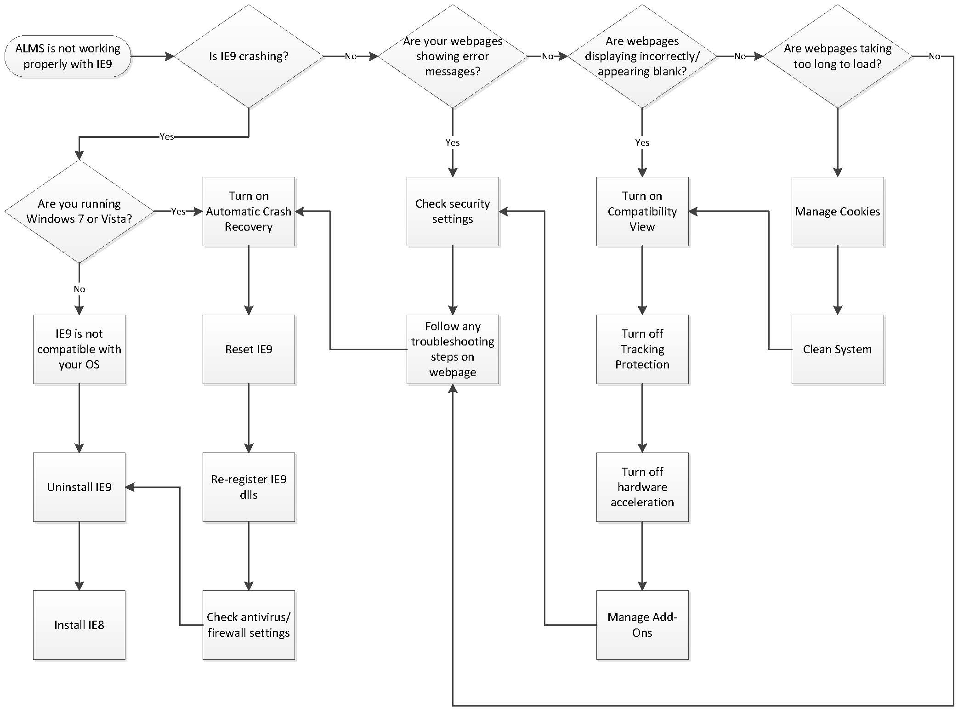
Table 2. Internet Explorer 9 Solution Guide
Problem | Solution
Uninstall IE9 | - Open Control Panel and click on “Programs and Features.”  - Click on “View installed updates” link given in left sidebar.  - You’ll see “Windows Internet Explorer 9” update listed there. Select the update and click the “Uninstall” button in toolbar or right-click on the update and select “Uninstall” option.  - Restart your computer. After restarting, IE9 will be removed from your system.
Install IE8 | To install IE8, go to: http://www.microsoft.com/en-us/download/details.aspx?id=43.
Turn on  Automatic Crash  Recovery | Internet Explorer stores certain info about the sites you visit on your PC in case there’s a crash, hang, or unexpected shutdown. This is called Automatic Crash Recovery, and it lets you pick up where you left off in case Internet Explorer unexpectedly closes. Automatic Crash Recovery stores the URL of each page you have open, each tab’s back/forward history, the arrangement of the tabs, and any info you’ve entered on the page. If you turn off Automatic Crash Recovery, Internet Explorer will still save info about your tabs, but you won’t be able to restore a lost browsing session or tabs.
Reset IE9 | Programs, such as Adobe Reader, HP Printer Applications, Download Managers, etc., add their own components to IE9 whenever you install them. These may create internal conflicts whereby IE9 problems arise. The most common among them are IE9 not responding, failure of Flash Player running, and IE9 crashing. These can be resolved by performing an IE9 reset:  - Open the Control Panel.  - Click Internet Options to open Internet Options dialog box.  - In the Internet Options dialog box, select the Advanced tab.  - Under the Advanced tab, click the last button labeled Reset.  - Click OK to close the Internet Options dialog box and start IE9.
Re-register IE9 dlls | Go to the command prompt and type the following and press Enter after each line.  regsvr32 softpub.dll  regsvr32 wintrust.dll  regsvr32 initpki.dll  regsvr32 dssenh.dll  regsvr32 rsaenh.dll  regsvr32 gpkcsp.dll  regsvr32 sccbase.dll  regsvr32 slbcsp.dll  regsvr32 cryptdlg.dll
Check Antivirus/  Firewall  Settings | Turn off the antivirus and firewall to see if your copy of IE9 is working properly. If turning off the antivirus helps, you may need to change the antivirus. This happens mostly in scenarios where you are using a free antivirus that has not been updated for IE9 yet.
Check Security  Settings | You can access the security settings from Control Panel.  - Click on the Internet Options in Control panel.  - In the resulting window, click to select the Settings tab.  - Use the slider to lower the security settings and see if your IE9 problems are fixed.
Turn on  Compatibility View | To turn on Compatibility View  - See if the Compatibility View button appears in the Address bar. (If you don’t see the button, there’s no need to turn on Compatibility View.)  - Tap or click the Compatibility View button to display the site in Compatibility View.  Once you turn on Compatibility View, Internet Explorer will automatically show that site in Compatibility View each time you visit. You can turn it off by tapping or clicking the button again. Or, you can clear the entire list of sites using Compatibility View by deleting your browsing history.
Turn off Tracking Protection/  InPrivate Filtering | - Open Internet Explorer for the desktop.  - Tap or click the Tools button, point to Safety, and then tap or click Tracking Protection.  - Tap or click Your Personalized List, and then tap or click Disable.
Turn off Hardware Acceleration | - Open Internet Explorer for the desktop.  - Tap or click the Tools button.  - Tap or click Internet Options.  - Tap or click the Advanced tab.  - Select Use software rendering instead of GPU rendering.  - Tap or click OK.  - You must close and reopen Internet Explorer for changes to take effect.
Manage  Add-ons | You can view, enable, and disable the list of add-ons that can be used by Internet Explorer for the desktop. Add-ons you can manage include browser helper objects, ActiveX controls, toolbar extensions, explorer bars, browser extensions, search providers, Accelerators, and Tracking Protection settings.  To manage add-ons  - Open Internet Explorer for the desktop.  - Tap or click the Tools button, and then tap or click Manage add-ons.  - Under Show, tap or click All add-ons, and then do one of the following:  - To disable an add-on, tap or click it, and then tap or click Disable.  - To enable an add-on, tap or click it, and then tap or click Enable.  - Tap or click Close.
Manage Cookies | Cookies are small text files that websites put on your computer to store information about you and your preferences. Some cookies might put your privacy at risk by tracking sites that you visit. To delete cookies in Internet Explorer  - Open Internet Explorer for the desktop.  - Tap or click the Tools button, point to Safety, and then tap or click Delete browsing history.  Select the Cookies check box, and then tap or click Delete.  - Open Internet Explorer for the desktop.  - Tap or click the Tools button, and then tap or click Internet options.  - Tap or click the Privacy tab, and then, under Settings, move the slider to the top to block all cookies or the bottom to allow all cookies, and then tap or click OK.  - Blocking cookies might prevent some pages from displaying correctly.
Clean System | Close IE9 and use a third party system cleaner, such as CCleaner, to clear the IE9 cache. This also helps in some cases where you are not able to load webpages.

Figure 2. Tips for Launching the Course
